МИНИСТЕРСТВО ОБРАЗОВАНИЯ РЕСПУБЛИКИ БЕЛАРУСЬ

УЧРЕЖДЕНИЕ ОБРАЗОВАНИЯ

“БРЕСТСКИЙ ГОСУДАРСТВЕННЫЙ ТЕХНИЧЕСКИЙ УНИВЕРСИТЕТ”

**ИНТЕЛЕКТУАЛЬНЫЕ ИНФОРМАЦИОННЫЕ ТЕХНОЛОГИИ**

ОТЧЁТ

По лабораторной работе № __

__________________________________________________

Выполнил:

Студент группы ИИ-22

Копанчук Евгений Романович

Проверил:

_________________

Брест – 2023

**Ход работы**

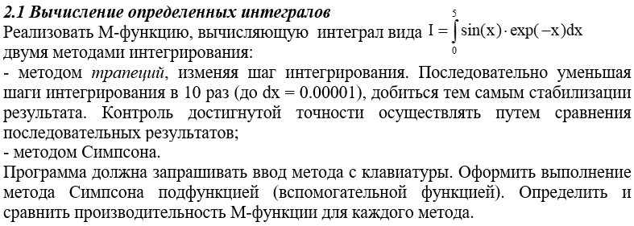

|  |
| --- |
| a = 0; b = 5;  f = @(x) sin(x) .* exp(-x);    MyIntegral(f, a, b, 0.0001)      function I = MyIntegral(f, a, b, acc)    method = input("Enter method (1. trapz / 2. quad): ");    if method == 1    x = a:acc:b;  y = f(x);  I = trapz(x, y);    else    I = Simpson(f, a, b, acc);    end    end    function I = Simpson(f, a, b, acc)  I = quad(f, a, b, acc);  end |

|  |  |
| --- | --- |
|  |  |

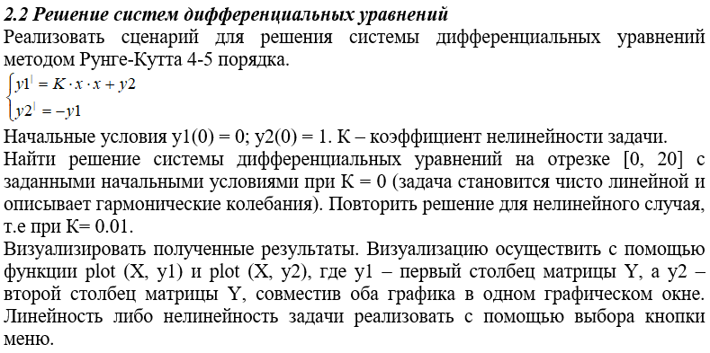

|  |
| --- |
| function L2T2_OpeningFcn(hObject, eventdata, handles, varargin)  RungeKutta(0);  end  function pushbutton1_Callback(hObject, eventdata, handles)  RungeKutta(0);  end    function pushbutton2_Callback(hObject, eventdata, handles)  RungeKutta(0.1);  end    function RungeKutta(K)  y0 = [0; 1]; tspan = [0, 20];  if K == 0  f = @(t, y) [y(2); -y(1)];  else  f = @(t, y) [0.01 * t .^ 2 + y(2); -y(1)];  end  [t, y] = ode45(f, tspan, y0);  plot(t, y(:,1), 'b', t, y(:,2), 'r', 'LineWidth', 2);  legend('y1', 'y2'); xlabel('t'); ylabel('y');  title(['Решение системы дифференциальных уравнений, K = ' num2str(K)]);  end |

|  |  |
| --- | --- |
|  |  |

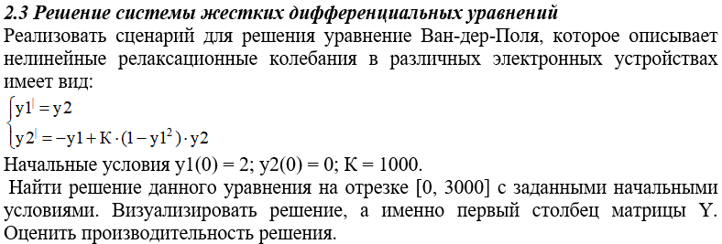

|  |
| --- |
| y0 = [2; 0]; tspan = [0, 3000]; h = 0.1;  f = @(t, y) [y(2); -y(1) + 1000 .* (1 - y(1) .^ 2) .* y(2)];  [t, y] = ode45(f, tspan, y0);  plot(t, y(:,1), 'b', 'LineWidth', 2);  legend('y1', 'y2');  xlabel('t'); WW  ylabel('y');  title(['Решение системы дифференциальных уравнений, K = ' num2str(K)]); |

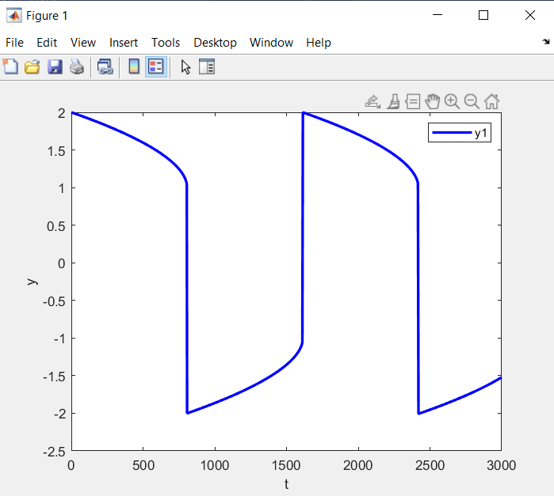

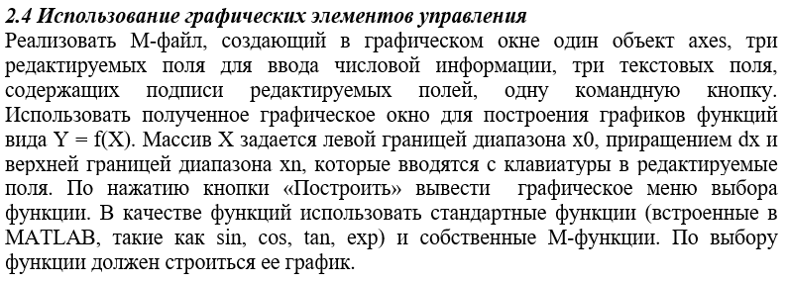

|  |
| --- |
| function L2T4_OpeningFcn(hObject, eventdata, handles, varargin)  global x0; x0 = 0;  global dx; dx = 0.01;  global xn; xn = 20;  global x; x = x0:dx:xn;  global f; f = @(x) sin(x);  end  function pushbutton1_Callback(hObject, eventdata, handles)  global f; f = @(x) sin(x);  end      function pushbutton3_Callback(hObject, eventdata, handles)  global f; f = @(x) cos(x);  end      function pushbutton4_Callback(hObject, eventdata, handles)  global f; f = @(x) tan(x);  end      function pushbutton5_Callback(hObject, eventdata, handles)  global f; f = @(x) cot(x);  end      function pushbutton6_Callback(hObject, eventdata, handles)  global f; f = @(x) sin(x) .^ 2 + cos(x) .^ 3 + tan(x) .^ 4 + cot(x) .^ 5;  end      function edit1_Callback(hObject, eventdata, handles)  global x; global x0; global dx; global xn;  str = get(hObject, 'String'); val = str2double(str);  x0 = val; x = x0:dx:xn;  end    function edit2_Callback(hObject, eventdata, handles)  global x; global x0; global dx; global xn;  str = get(hObject, 'String'); val = str2double(str);  dx = val; x = x0:dx:xn;  end    function edit3_Callback(hObject, eventdata, handles)  global x; global x0; global dx; global xn;  str = get(hObject, 'String'); val = str2double(str);  xn = val; x = x0:dx:xn;  end    function pushbutton8_Callback(hObject, eventdata, handles)  global x; global f;  plot(x,f(x),'b','LineWidth',2); legend('y = f(x)'); xlabel('x'); ylabel('y');  end |

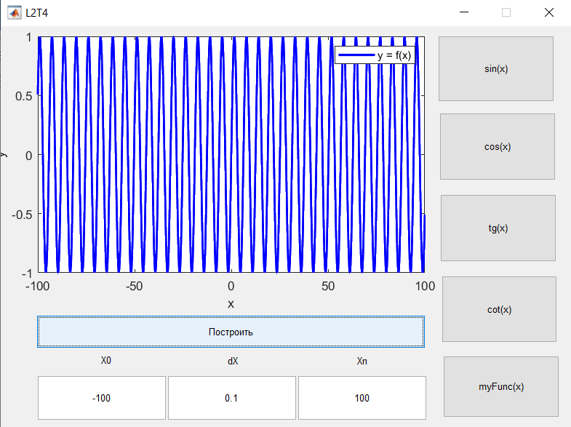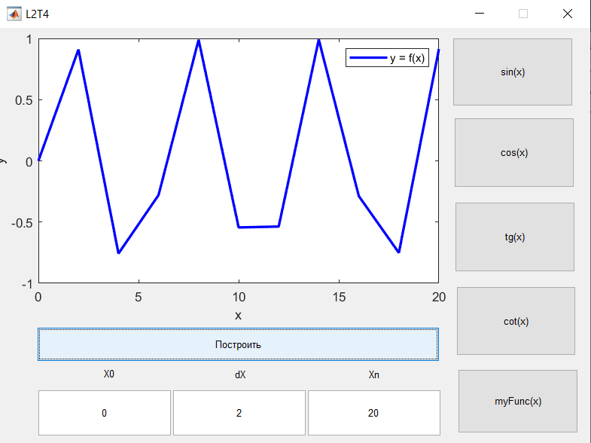

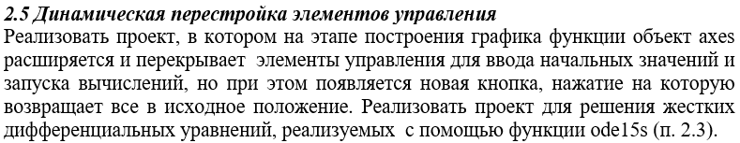

|  |
| --- |
| function L2T5_OpeningFcn(hObject, eventdata, handles, varargin)  global y0; global tspan; global f; global axes_pos;  y0 = 0; tspan = [0, 5]; f = @(t, y) -20*y + 10*sin(t);  handles.output = hObject; guidata(hObject, handles);  end  function pushbutton1_Callback(hObject, eventdata, handles)  set(hObject, 'Visible', 'off'); set(handles.text1, 'Visible', 'off');  set(handles.text2, 'Visible', 'off'); set(handles.text3, 'Visible', 'off');  set(handles.text4, 'Visible', 'off'); set(handles.edit1, 'Visible', 'off');  set(handles.edit2, 'Visible', 'off'); set(handles.edit3, 'Visible', 'off');  global axes_pos; axes_pos = get(handles.axes1, 'Position');  set(handles.axes1, 'Position', [0, 0, 114.7, 32.4]);  set(handles.pushbutton2, 'Visible', 'on');  global y0; global tspan; global f; [t, y] = ode15s(f, tspan, y0);  plot(t, y, 'y', 'LineWidth', 2); legend('y = f(x)'); xlabel('x'); ylabel('y')  end    function edit1_Callback(hObject, eventdata, handles)  global y0; y0 = str2double(get(hObject, 'String'));  end    function edit2_Callback(hObject, eventdata, handles)  global tspan; tspan = [str2double(get(hObject, 'String')), tspan(2)];  end  function edit3_Callback(hObject, eventdata, handles)  global tspan; tspan = [tspan(1), str2double(get(hObject, 'String'))];  end    function pushbutton2_Callback(hObject, eventdata, handles)  set(hObject, 'Visible', 'off'); set(handles.text1, 'Visible', 'on');  set(handles.text2, 'Visible', 'on'); set(handles.text3, 'Visible', 'on');  set(handles.text4, 'Visible', 'on'); set(handles.edit1, 'Visible', 'on');  set(handles.edit2, 'Visible', 'on'); set(handles.edit3, 'Visible', 'on');  global axes_pos;  set(handles.axes1, 'Position', axes_pos); set(handles.pushbutton1, 'Visible', 'on')  end    function pushbutton2_CreateFcn(hObject, eventdata, handles)  set(hObject, 'Visible', 'off');  end |

|  |  |
| --- | --- |
|  |  |